Certified Staff
Negotiated Agreement

for

Rawlins County USD #105

of
Atwood and Herndon
Rawlins County, Kansas

2014-15

Duty Day : 7:45 – 4:00

The following is the negotiated agreement between the Board of Education, USD #105, and the teacher association here in referred to as Rawlins County K-NEA. This agreement becomes effective July 20, 2010.

TABLE OF CONTENTS

ARTICLE SUBJECT OF ARTICLE
I General Provisions
I-A Savings Clause
I-B Recognition Clause
II Association Rights
III Distribution of Agreement
IV Policies
IV-A Written Board Policy
V Curriculum
VI In-service
VII Teacher Contracts
VII-A Performance of Services
VII-B Assignment
VII-C Licensure / Certification
VII-D Tenure
VIII Salary Payment Date
VIX Contractual Days
X Health Insurance
XI Professional Dues
XII Leaves
XII-A Sick Leave Days
XII-B Payment for Sick Leave over 90 Days
XII-C Personal Days
XII-D Extra Personal Days
XII-E Deduction for Additional Leave
XII-F Reporting of Leave Days
XII-G Extended Leave for Teachers
XII-H Jury Duty
XIII Early Retirement Plan
XIV Payment of Accumulated Unused Sick Leave
XV Additional College Hours
XVI Assigned Duties
XVII Duty Free Lunch Period
XVIII Resignation / Release from Contract
XIX Evaluations
XX Working Requirements
XX-A Lesson Plans
XX-B Attendance at School Functions
XX-C Teacher Responsibility
XXI School Calendar
XXII School Visitations
XXIII Salary Schedule
XXIV Coaching and Extra Duty Salary Schedule
XXV Protected Teacher Worktime
XXVI RIF Policy
XXVII Fair Dismissal of Teachers

ARTICLE I: GENERAL PROVISIONS
I-A: Savings Clause
If any provision of this Negotiated Agreement or any application of this Negotiated Agreement to any employee or group of employees is held to be contrary to law, then such provision or application shall not be deemed valid or subsisting, except to the extent permitted by law, but all other provisions or applications shall continue in full force and effect.

I-B: Recognition Clause
The District Board of Education officially recognizes the Rawlins County Teachers’ Association (aka Rawlins County K-NEA) for the purpose of professional negotiations under KSA 72-5413 et. seq. as the exclusive representative for the teachers’ unit of the professional employees.

The bargaining unit shall be defined as those employees of the district in positions which require a certificate (license) issued by the State Department of Education but shall not mean any such person who is an administrative employee.

ARTICLE II: ASSOCIATION RIGHTS
The Rawlins County Teachers’ Association shall be permitted to use the buildings for association activities prior to 7:45 a.m. and/or after 4:00 p.m. With prior approval from the building administrator or superintendent, the association shall have access to school equipment when it is not being used for other school business.

ARTICLE III: DISTRIBUTION OF AGREEMENT
When negotiations are successfully completed and agreements are signed, the district will provide each teacher a copy of the agreement and six (6) additional copies for use by the teachers’ association. Any teacher who is hired by the district after the completion of negotiations will be given a copy of the agreement when they are hired.

ARTICLE IV: POLICIES
IV-A Written Board Policy - Policy Handbook
The Board shall maintain an accurate and up-to-date written compilation of its adopted policies. Terms and conditions of professional service are negotiable and will be placed under the appropriate titles in the Written Board Policy.

One copy of the USD #105 Policy Handbook will remain in each school on May 30 of each school year. All other copies will be removed for necessary revisions and will be available to the teachers on the first day of in-service preceding the first day of the following school year. Rawlins County K-NEA will appoint a committee to assist in recommending policy revisions and will share the responsibility to see that this committee meets. The superintendent is to take the initiative to organize the date and time of the meetings. Final recommendations from this committee shall be due before the third Monday in June of each year.

ARTICLE V: CURRICULUM
Standing committees for different areas in QPA and curriculum will be mutually appointed by the staff and the administration.

Teachers will be compensated at a rate of $10.00 per hour for QPA and curriculum work completed outside the regular school or in-service day. The approved documentation form will be used to record the hours worked. It is the responsibility of the teacher to maintain said document and submit it to the central office for payment.

ARTICLE VI: IN-SERVICE
A committee of four teachers, one from each building level in each attendance center shall form the district’s Professional Development Council (PDC). The PDC shall work with the administrative team to help develop and implement decisions concerning teacher in-service. In-service should be geared toward the needs of the district as defined in the school improvement plan and the district staff development plan. The PDC shall oversee and administer the district’s staff development plan.

ARTICLE VII: TEACHER CONTRACTS
VII-A. Performance of Services
The teacher will perform the following services in conformity with Kansas law and the policies of the board:
- To teach all days when school is regularly scheduled
- To make and file all reports required by the board, and/or administrators
- To attend professional meetings authorized by the board and/or administrators
- To cooperate with the administrators and other teachers in planning and coordinating the teaching program.
- To perform such school services as directed by the board and/or administrator.

VII-B. Assignment
The board reserves the right to assign the teacher to such buildings and work as the best interests of the schools of the district require.

VII-C. Licensure / Certification
The contract between the district and the teacher shall be null and void if the teacher fails to have on file with the board continuously during employment with the district a valid Kansas Teaching License (Teaching Certificate) for the level at which he/she is employed and/or for the subjects for which he/she is employed to teach.

VII-D Tenure
Tenure is granted to all current eligible staff. (6/21/04)

ARTICLE VIII: SALARY PAYMENT DATE
Salary will be paid on or about the 20th of each month and such statement is placed in the policy handbook. When the 20th falls during a weekend or holiday, pay day will be the last day before the 20th that school is in session.

ARTICLE VIX: CONTRACTUAL DAYS
The contractual obligation of the certified staff member will not be more than 185 days.

Changed 5-20-13

ARTICLE X: HEALTH INSURANCE
The Board of Education will pay up to $6,400.00, towards a single health insurance policy for all members of the teaching staff. If this does not cover the cost of the entire policy, then all teachers would be allowed to pay the remaining premium cost through before tax dollars.

Changed 5-20-13

ARTICLE XI: PROFESSIONAL DUES
Professional dues may be handled through payroll deduction. The secretary-treasurer of Rawlins County K-NEA shall provide a list of teachers requesting such deductions and the total amount of each deduction to the clerk of the board by September 15th of each year.

ARTICLE XII: LEAVES
XII-A. Sick Leave Days:
Ten (10) days sick leave per year accumulative to ninety (90) days. Reasonable bereavement leave will be granted and counted against sick leave days. Reasonable bereavement leave will be defined as three days. Additional bereavement days may be considered. Accumulated leave days will transfer from Atwood USD 318 and Herndon USD 317 to Rawlins County USD 105.

XII-B. Payment for Sick Leave over 90 Days:
This applies only to those teachers who have accumulated 90 days of sick and personal leave. Pay for annual allowable unused days will be at the rate of 40% of whatever the rate of pay is for the basic salary of a substitute teacher.

Example: Staff member ends year with 87 days. Add 10 days for the following year would put him/her over 90 days. (97 days). During this year the staff member uses only 2 days (95 days remaining) so the staff member would be paid for 5 days (the number of unused days over 90).

XII-C. Personal Days:
Five (5) days out of the ten (10) sick leave days may be used for personal days. At the end of each year, any unused personal days will be transferred to the sick leave total. Teachers are requested to avoid using personal leave the day preceding or the day following a school observed holiday or the last 5 days of the school year whenever possible. Personal days will be approved at the discretion of administration.

Changed 5-20-13

XII-D. Extra Personal Days:
There may be times a staff member feels he/she needs more than five (5) days of personal leave. When this does occur, the staff member may request additional days IN WRITING through the principal and the superintendent. Both the principal and the superintendent must approve the request. If the staff member's request is denied the staff member may go before the Board of Education with the request to try to obtain its approval.

XII-E. Deduction for Additional Leave
Any additional leave accumulation will be charged to the teacher at a rate of 1/185th of contract salary. The deduction may be spread over the remainder of the contract period. This will be based on a written request to the Clerk of the USD 105 Board of Education by the requesting staff member.

XII-F. Reporting of Leave Days
The number of accumulated days used and the days remaining will be printed each month on the payroll stub.

XII-G. Extended Leave for Teachers
LEAVE: Extended leave, for either one single semester or one school year, would be an option for teachers who have actually taught in USD 105 (with credit for years taught in USD 318 and USD 317) for a cumulative total of ten years. Ten years is not to be defined as the tenth step on the salary schedule, but as a total of ten years Atwood USD 318 / Herndon USD 317 / Rawlins County USD 105 teaching experience over any time span. Granting of leave request would not be contingent upon the teacher's activity during the period of leave.

NOTIFICATION: The teacher shall file a written request for extended leave in the superintendent's office no later than 90 days prior to the end of the semester which precedes the requested leave time.

There would be no pay or benefits during extended leave time. During this leave the teacher could continue health insurance coverage within the district group plan but at the teacher's own expense. There would be no loss of accumulated sick leave but neither would there be the addition of earned sick leave during this time.

Upon return to teaching duties, the teacher would be placed on the salary schedule at the experience position (vertical column) immediately following the salary schedule position of his/her most recent contract. Educational position (horizontal row) placement would be granted as appropriate upon return based upon the most recent college transcript.

Leave would be granted contingent upon the district being able to obtain an acceptable certified replacement teacher for that teacher's duties during the leave time. The certification of the replacement teacher must be specific for the teaching duties he/she will assume.

There will be no change of teaching assignment upon the teacher's return unless agreed to prior to the leave being taken or mutually agreed to by the teacher and administration upon return from leave.

Supplemental contract duties will not be a factor in granting extended leave. Arrangements for supplemental contract duties would be an individual matter to be settled between the administration and teacher.

The teacher will be required to give written notice to the district prior to March 1 if not planning to return to employment at the end of a year leave or second semester leave. If the leave applies only to the first semester time period, the teacher will be required to give written notice to the district prior to October 15.

A teacher's request for continuation of the initial leave may be granted at the board's discretion.

The USD 105 Board of Education and administration will strive to cooperate with the teaching staff in cases where the opportunity exists for taking advanced curricular-based classes not offered in the immediate Atwood/Herndon area.

XII-H Jury Duty
Teachers are entitled to as many days of paid leave as are necessary if they are called to serve on a jury, provided they sign over to the district all compensation except that designated for auto allowance and living expenses.

ARTICLE XIII: EARLY RETIREMENT PLAN
An early retirement plan has been established. The guidelines for which will be attached as Appendix A to this agreement.

ARTICLE XIV: PAYMENT OF ACCUMULATED UNUSED SICK LEAVE
The district will compensate district employees for unused sick leave in accordance with the following guidelines:

1. Limitations Payment in accordance with these provisions will be made only in the event of medical disability, death, retirement, or resignation. Should there be changes in state or federal law during the term of this agreement, those changes shall be interpreted to apply to this agreement as if the agreement were specifically modified to conform to applicable law.

2. Scope There will be payment at a rate of 40% of whatever the rate of pay is for the basic salary of a substitute teacher (up to 90 days) for employees leaving service with USD #105 who have 10 years or more of continuous service in USD #105. Credit will be given for the years of service with USD #318 and USD #317.

ARTICLE XV: ADDITIONAL COLLEGE HOURS
Any teacher requested by the school district to take additional college hours shall be considered by the Board of Education on an individual basis for reimbursement of tuition costs.

ARTICLE XVI: ASSIGNED DUTIES
Specific non-paying duties to which a teacher may be assigned such as co-class sponsor, Science Club sponsor, etc., will be added to the policy handbook. These non-paying duties will be added to contracts when such duty is known at the time of the issuing of contracts.
These assignments can be changed by mutual consent.

ARTICLE XVII: DUTY FREE LUNCH PERIOD
Lunchroom supervision will be handled by a paraprofessional.

ARTICLE XVIII: RESIGNATION / RELEASE FROM CONTRACT
Teachers who do not honor their contractual obligations will be penalized according to the following schedule:

The Board of Education must notify teachers of non-renewal by the third Friday in May, and the teacher has 14 calendar days from then, to notify the Board of Education with their written resignation without penalty.

Releases 1 day-4 weeks after the deadline $400. penalty
Releases 4 weeks-8 weeks after the deadline $1200. penalty
Releases 8 weeks and beyond from the deadline $1800. penalty

After August 15, releases will be allowed only in extreme emergencies.

The above schedule will be in effect unless a release is mutually agreed upon and provided a suitable replacement is available.

Changed 5-20-2013

ARTICLE XIX: EVALUATIONS
Number of Observations
Every employee in the first two consecutive school years of employment shall be evaluated at least one time per semester by no later than the 60th school day of the semester. Every employee during the third and fourth years of employment shall be evaluated at least one time each school year by no later than February 15. After their fourth year of employment every employee shall be evaluated at least once every three years by no later than February 15 of the school year. Teachers who have been tenured in another district will be evaluated at least once a year for the first two years by no later than February 15. Further evaluation observations may be scheduled or unscheduled through discussion with staff member and administrator.

Pre-Observation Conference
At least five days prior (unless mutually agreed to otherwise) to any observation the evaluator shall meet with the teacher to discuss the following; examples could include: a)What outcomes does the teacher anticipate for the lesson which will be presented on the day of the observation, b)What methods of instruction will the teacher use to present the lesson on the day of the observation, c)What materials will be used for the lesson being presented on the day of the observation, and d)Are there any special events or problems the teacher wishes the evaluator to observe?

The evaluator and teacher will identify any specific skills or teaching practices they wish to observe and determine the best time to observe those skills or practices. The evaluator and teacher shall also identify any specific problem areas they believe need to be monitored or changed. The evaluator shall also identify any specific portions of the evaluation form he/she will be focusing on. A copy of the evaluation form will be given to the teacher at or prior to this conference.

Number of Observations
The evaluator shall make at least 2 classroom observations of 45 minutes each, prior to the completion of the evaluation form.

Post-Conference Meeting
A post-observation conference will be held between administrator and teacher following each classroom observation. The conference shall include the following items: assess all observation notes as completed by the evaluator, discuss all points identifying strengths and weaknesses.

Self-Evaluation
Prior to the evaluation conference, the teacher shall complete a self-evaluation. If there is a need, the teacher and administrator may discuss the self-evaluation together.

Evaluation Training
Staff will be trained on the current evaluation document prior to being evaluated each year.

Plan of Improvement
If a teacher is marked in the lowest performance category within one or more area(s) on their evaluation; the administrator and teacher shall work to arrive at a Plan of Improvement to correct those areas.

Changed 5-20-13

ARTICLE XX: WORKING REQUIREMENTS
XX-A. Lesson Plans
Teachers are to maintain daily lesson plans in their classrooms. These lesson plans shall be maintained for one week in advance. These plans shall be located in a designated location* in the teacher's classroom. These plans are subject to the building principal's approval through periodic lesson plan inspections. It shall be the responsibility of the teacher to maintain the lesson plans. These plans may be used by a substitute teacher if a dire emergency arises. In the event, other than a dire emergency, of a teacher's absence that teacher shall submit in-depth lesson plans to the principal for the substitute teacher to insure the continuity of the class during the absence of the teacher.

*The principal of each building shall maintain a list of teachers with each designated location for lesson plans on the list

If, during the principal's inspection of the lesson pans, the lesson plans are found not to be maintained by the teacher, a letter of reprimand will be written at the principal's discretion and placed in the teacher's personal file.

XX-B. Attendance at School Functions
The Board of Education and the Teacher's Association should encourage attendance at school functions.

XX-C. Teacher Responsibility
All teachers are responsible for conduct of students at school and at school activities. The administration will support reasonable disciplinary action taken by teachers at such events.

ARTICLE XXI: SCHOOL CALENDAR
The faculty may have input for the beginning and ending dates of summer vacation, holidays, breaks, and in-service days. These suggestions concerning the next year’s calendar shall be submitted to the central office when requested by the administration.

A master calendar will be set up with activities of all schools listed. The calendar will be published by the district office.

ARTICLE XXII: SCHOOL VISITATION
Teachers will be provided with one (1) day a year to visit another school and observe teaching methods and techniques to broaden and better his/her own teaching ability and skills. No more than two teachers should be gone from each building on a given day, and a visitation day should not be used in conjunction with a holiday or personal business. Teachers will be required to give a report to the staff in their respective buildings following a school visitation.

ARTICLE XXIII: SALARY SCHEDULE
A copy of the teachers’ salary schedule, as modified each year, shall be attached to this agreement as Appendix B.

Conditions for implementing the salary schedule shall be as follows:
- Vertical steps on the salary schedule do not necessarily mean years of experience. However, it will be used as a guide in hiring new personnel;
- To advance horizontally, hours must be gained in the field of study which would apply to an advanced degree unless approved by the administration;
  - IDP (Individual Development Plan) points may be used to advance horizontally on the salary schedule, in conjunction with college credits. See details below:
    - 20 IDP points equals 1 college credit, with a maximum of 3 college hours / 60 points allowable per column movement. A minimum of half the 60 points must be above knowledge level.
    - IDP points beginning from August 1, 2009
    - Teacher must submit a written request to the unified office requesting transfer of PDC points to college hours with accompanying documentation of PDC points.
    - Request must be submitted by August 1st
- The Board of Education reserves the right to vary from the schedule if it deems necessary.
- New vertical steps may be added to any or all salary schedule columns through negotiations. Otherwise, teachers at the bottom of a salary schedule column will receive only the amount of increase provided by the elevation of the base as applied to the teacher’s current position on the schedule.

ARTICLE XXIV: COACHING AND EXTRA DUTY SALARY SCHEDULE
A copy of the coaching and extra duty salary schedule, as modified each year, shall be attached to this agreement as Appendix C. The base for the extra duty salary schedule will be tied to the base for the regular salary schedule.

ARTICLE XXV: PROTECTED TEACHER WORK TIME
A minimum of one work day in August will be without meetings, etc.

ARTICLE XXVI: RIF POLICY – added 6-17-13

GBQA Reduction in Certified Staff (Tenured) GBQA
The Board has the responsibility of determining composition of the professional staff necessary to implement and maintain the educational programs of Unified School District #105. A decision to reduce professional staff will, in all cases, remain within the sole discretion and judgment of the Board of Education. The Board of Education may retain any professional employee who it deems necessary to staff any program in the school district. It is the policy of this Board to use normal attrition of staff (i.e. resignations, retirement, leave of absence) as the first means of achieving the necessary reduction of professional staff. In the event that further reduction of professional staff is necessary, it shall be accomplished in a fair and orderly manner as provided in this policy.

GBQA-R Reduction in Certified Staff (Tenured) GBQA-R
Whenever the superintendent determines that a necessary reduction of professional staff will not be accomplished through normal attrition of staff, all professional employees of the school district will be advised of the reasons for the reduction of professional staff and will be informed of the procedures and considerations to be used in determining which employees will have their contracts non-renewed. The superintendent will review all relevant facts and circumstances and will present to the Board of Education the names of those professional employees whose contracts are recommended for non-renewal. The educational needs of the school district will be the primary criteria used in making the decisions on reduction in personnel.
In making those determinations included in the preceding paragraph, the superintendent shall give consideration to the following factors:
1) Areas of certification;
2) Educational performance as determined from the certified employee evaluations;
3) Prior teaching and/or appropriate experience in specific service areas;
4) Advanced degrees or additional credit hours;
5) Seniority in the district;
6) Building Principal’s recommendation.
GBQA-R Reduction in Certified Staff (Tenured) GBQA-R-2
Recall
Those employees who have been terminated through a reduction in force may be offered re-employment within the district within a period of two (2) years from the end of the current contract when vacancies occur for which they are qualified. At re-employment, the employee shall retain any benefits which had accrued to said employee at the time of termination. The length of time represented by the break in service shall not be included as service with the district. The employee shall be responsible for maintaining his or her address, telephone number and certification within the district’s administration office. When a vacancy occurs, notice of the vacancy will be sent to employees and they may be offered re-employment in reverse order of the order in which they were laid off.

ARTICLE XXVII: FAIR DISMISSAL OF TEACHERS – added 9-2-14

- The BOE and Association agree to the mutual benefit of the Fair Dismissal procedure for experienced teachers. This provision balances the relative security earned through an extended and successful probationary period with employer expectations of continued quality professional performance.
- For the first three years of professional employment with the district, teachers, are considered probationary and may be nonrenewed prior to the statutory deadline for any reason except as protected by Constitutional or other nondiscrimination protections.
- Starting in year four of teaching with the district, teachers shall have earned nonprobationary status. At its discretion, the Board may formally grant nonprobationary status to any teacher earlier.
- Nonprobationary teachers may be terminated or nonrenewed for just cause, including ineffective performance, provided the procedural process is closely observed. While timelines are expected to be followed, extenuating circumstances may be considered for minor procedural errors. If the proposed nonrenewal is to be based on ineffective performance, the district evaluation procedure shall be followed. The nonprobationary teacher will be informed his/her performance is substandard and the full evaluation process will be utilized, including a measurable plan of improvement. The plan of improvement shall be collaboratively developed but the final decision on the plan rests with the principal.
- If the termination or nonrenewal is based on other reasons, including disciplinary factors or reduction of force, those separate procedures as outlined in the Agreement shall be followed prior to the termination or nonrenewal.
- If the nonprobationary teacher is terminated or nonrenewed, he/she shall be notified in writing prior to the statutory continuing contract date. The notification shall include the reasons for termination or nonrenewal. The teacher will have fourteen calendar days from the postmark/witnessed hand-delivery of the letter to file a written request with the Board Clerk for a hearing.
- Within seven calendar days, the parties shall meet and select a mutually agreeable party to be the hearing officer. If that is not possible, the hearing officer shall be an arbitrator selected by alternately striking names from either the KSDE list or the AAA list.
- During the hearing, the entire basis for the termination or nonrenewal shall be proffered by the district and the teacher may present his/her response. If, in the opinion of the hearing officer, more time and/or information is needed for an appropriate decision, it shall be allowed. Otherwise, the hearing shall be closed at the end of the presentations. The decision by the hearing officer shall solely determine whether to sustain or reverse the termination/nonrenewal and shall be rendered in writing to both parties within seven calendar days.
- It is the intention of the parties that the decision be rendered prior to August 1 and all reasonable efforts should be made to accomplish that goal.
- If the teacher prevails, he/she is reinstated in full. If the BOE prevails, the job action is final. The decision is binding on both parties provided that either party may appeal a decision it believes arbitrary or capricious.
- The teacher shall pay for his/her expenses, including any witness and/or representation. All other expense of the hearing shall be paid by the district.
SUNSET PROVISION – This provision shall be effect for the 2014-2015 school year and will not be included in subsequent agreement sunless expressly agreed to.

APPENDIX A

RAWLINS COUNTY U.S.D. #105 - EARLY RETIREMENT PLAN

The Early Retirement Policy of Rawlins County Unified School District 105 immediately becomes null and void if such policies, in regard to public school districts in Kansas, are found to be in violation of the Kansas cash-basis laws or ruled to be unconstitutional by the Kansas Attorney General, state courts, or federal courts. The Early Retirement Plan is no longer a stand-alone plan. Rather, the term “Early Retirement Plan” is a term of convenience that describes the employer contributions to be made to a 403(b) account for certain employees who become eligible for the contributions, as set forth below, subject to the following eligibility criteria, which criteria shall be made a part of the 403(b) plan.

1. Employees of the school district who may find it necessary or desirable to retire from employment with the district prior to normal retirement age, may elect to take early retirement under the terms and conditions set forth in this policy. Early retirement is entirely voluntary and at the discretion of an eligible employee.
2. Eligibility: An employee is eligible for early retirement if such employee:
Age 60-64:
a) has 20 years of teaching credit in Kansas Public Schools or 20 years of service credit
b) is currently a full-time professional employee of the school district with 10 or more years of employment service with the district, with credit for years of experience in USD 318 and USD 317.
c) is not more than 65 years of age on July 1 of the year that early retirement benefits would begin.
Age 55-59:
a) is currently a full-time professional employee of the school district with 25 or more years of employment service with the USD 105, USD 318, and USD 317 and is at least 55 years of age but less than 60 years of age on July 1 of the year early retirement benefits begin.

Eligibility, i.e., compliance with a) through c) above, will be determined by the Board of Education. An employee applying for early retirement shall have the responsibility to provide all facts and information necessary to prove eligibility for early retirement and to determine benefits to be paid.
3. Early Retirement Benefits: A yearly payment of $7,000 will be put into a 403(b) plan account in the teacher’s name in September following the teacher's retirement, and the teacher’s account shall receive equal payments each year until the year the teacher reaches age 65 on or before August 31. The total benefit placed into a teacher’s account is $35,000 or $7,000 per year, which ever is the least.

An employee age 60 to 64 inclusive will receive the full amount of the stipend if they have 20 years of service in USD 105, USD 318 and USD 317, 80% of the stipend with 15 years of service in USD 105, USD 318 and USD 317 and 60% of the stipend with 10 years of service in USD 105, USD 318, and USD 317 as a certified employee.

An employee age 55 to 59 inclusive must have at least 25 years of employment service with USD 105, USD 318 and USD 317 as a certified employee.
4. Application: An employee may apply for early retirement by completing an application form and submitting it to the Superintendent. Such written notice shall be submitted on or before the first (1st) day of April preceding the anticipated retirement date. Any request for early retirement submitted after the April 1 deadline will be considered by the Board of Education if reasons for the delayed request are attached to the application. Application forms are available at the district office.

Following final action on any application for early retirement, the Superintendent shall notify the applicant, in writing, of the final disposition and the date and amount of early retirement benefits to be paid to the teacher’s 403(b) account, as provided under the 403(b) plan.
5. Terms and Conditions: The following terms and conditions shall apply to the school district's early retirement plan:
a) Any eligible application for early retirement shall be granted by the Board of Education;
b) The annual early retirement benefit will be payable by the school district in an amount equal to $7000.00 each year.
c) An employee taking early retirement shall have the option to maintain health insurance coverage through the school district's health insurance program. The employee will pay to the district the amount of the monthly premium. The payment must be received in the district office by the 10th of each month to maintain the membership in the health insurance plan. This payment will be acceptable until the age of 65 or until the district is notified, in writing, of the employee’s desire to discontinue the district insurance.
d) No benefits will occur after the date of death.
e) An employee who takes early retirement shall have the responsibility to keep the school district informed of his or her current mailing address and telephone number.
f) If any provision of this early retirement plan is determined to be in violation of federal or state laws or regulations, then the entire plan shall immediately terminate and shall be of no further force of effect unless readopted by the Board of Education.

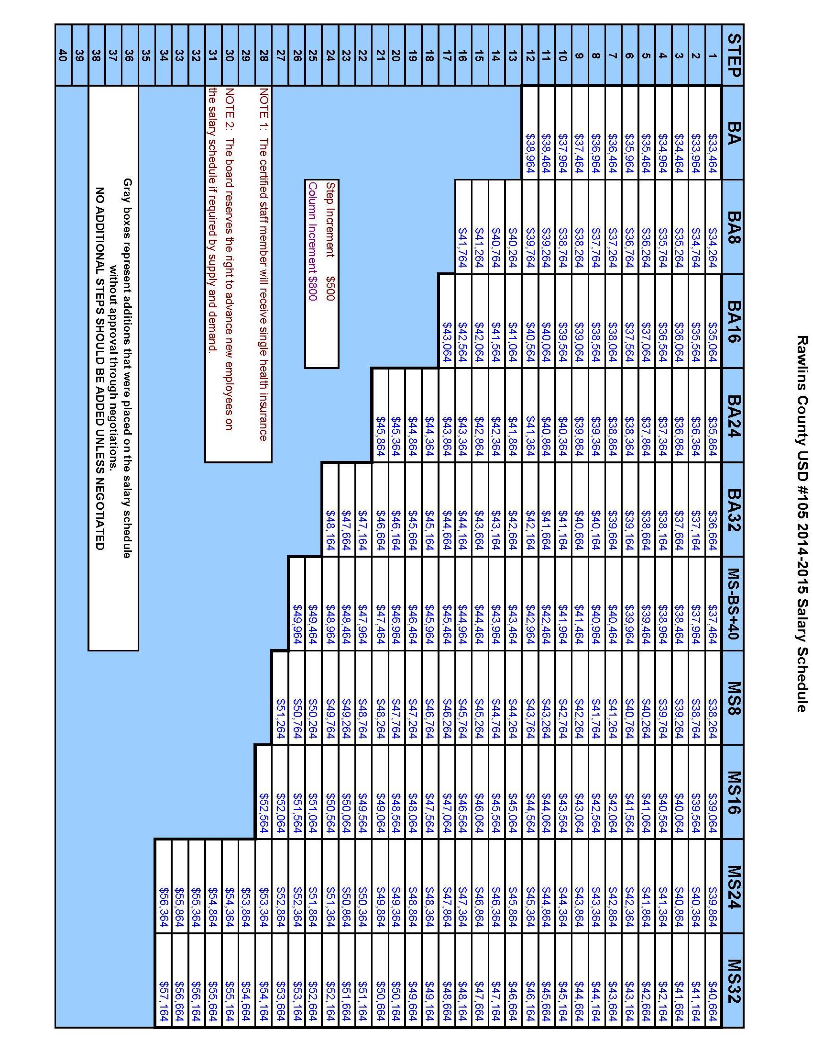
APPENDIX B

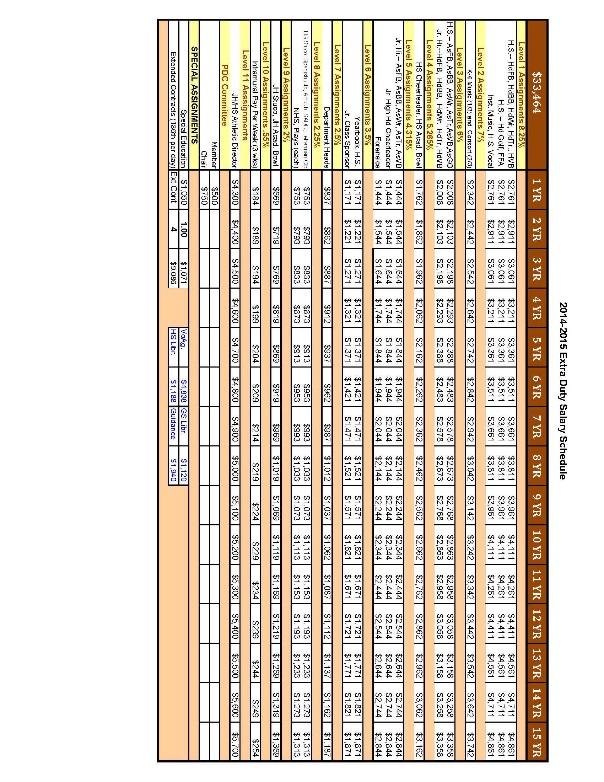
APPENDIX C

